

***NAMAL UNIVERSITY MIANWALI***

***DEPARTMENT OF ELECTRICAL ENGINEERING***

***Communication Systems (Lab)LAB # 07***

***REPORT***

***Title :***

***Frequency Modulation and Demodulation***

|  |  |
| --- | --- |
| ***Name*** | ***Riaz Ud Din*** |
| ***Roll No*** | ***NIM-BSEE-2021-36*** |
| ***Intructor*** | ***Dr. Sajjad Ur Rehman*** |
| ***Lab Engineer*** | ***Engr. Faizan Ahmad*** |
| ***Date Performed*** | ***22-April-2024*** |
| ***Marks*** |  |

% Parameters

fm = 10; % Message signal frequency (Hz)

Am = 1; % Message signal amplitude

theta_m = 0; % Message signal phase

fs = 10000; % Sampling frequency

fc = 500; % Carrier frequency (Hz)

Ac = 1; % Carrier amplitude

theta_c = 0; % Carrier phase

freq_dev = 250; % Frequency deviation factor

% Time scale

t = 0:1/fs:0.1; % Time scale for one time period of the message signal

% Message signal

message_signal = Am * cos(2*pi*fm*t + theta_m);

% Modulation

modulated_signal = fmmod(message_signal, fc, fs, freq_dev);

% Demodulation

demodulated_signal = fmdemod(modulated_signal, fc, fs, freq_dev);

% Magnitude spectrum of input signal

input_spectrum = abs(fft(message_signal));

% Magnitude spectrum of demodulated signal

demodulated_spectrum = abs(fft(demodulated_signal));

% Carrier signal

carrier_signal = Ac * cos(2*pi*fc*t + theta_c);

% Plotting

figure;

subplot(1,2,1);

plot(t, message_signal);

title('Message Signal');

xlabel('Time (s)');

ylabel('Amplitude');

grid on;

subplot(1,2,2);

plot(t, carrier_signal);

title('Carrier Signal');

xlabel('Time (s)');

ylabel('Amplitude');

grid on;

figure

subplot(1,2,1);

plot(t, modulated_signal);

title('Modulated Signal');

xlabel('Time (s)');

ylabel('Amplitude');

grid on;

subplot(1,2,2);

plot(t, demodulated_signal);

title('Demodulated Signal');

xlabel('Time (s)');

ylabel('Amplitude');

grid on;

figure;

subplot(1,2,1);

plot(abs(input_spectrum));

title('Magnitude Spectrum of Input Signal');

xlabel('Frequency (Hz)');

ylabel('Magnitude');

grid on;

subplot(1,2,2);

plot(abs(demodulated_spectrum));

title('Magnitude Spectrum of Demodulated Signal');

xlabel('Frequency (Hz)');

ylabel('Magnitude');

grid on;

% Adjusting layout

sgtitle('Frequency Modulation and Demodulation');

***Output:***

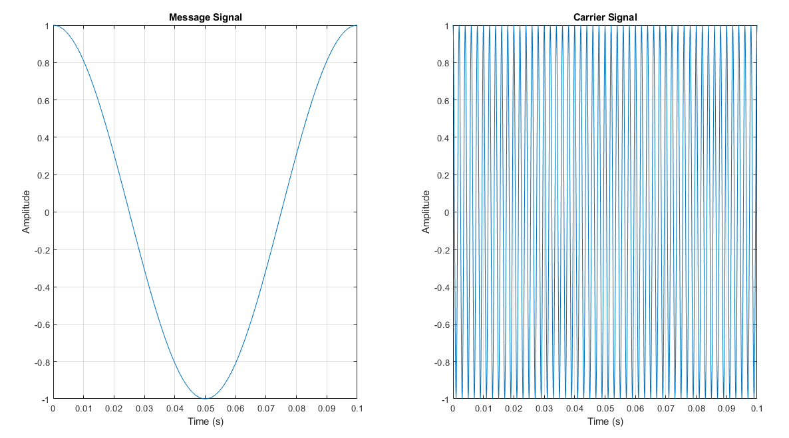

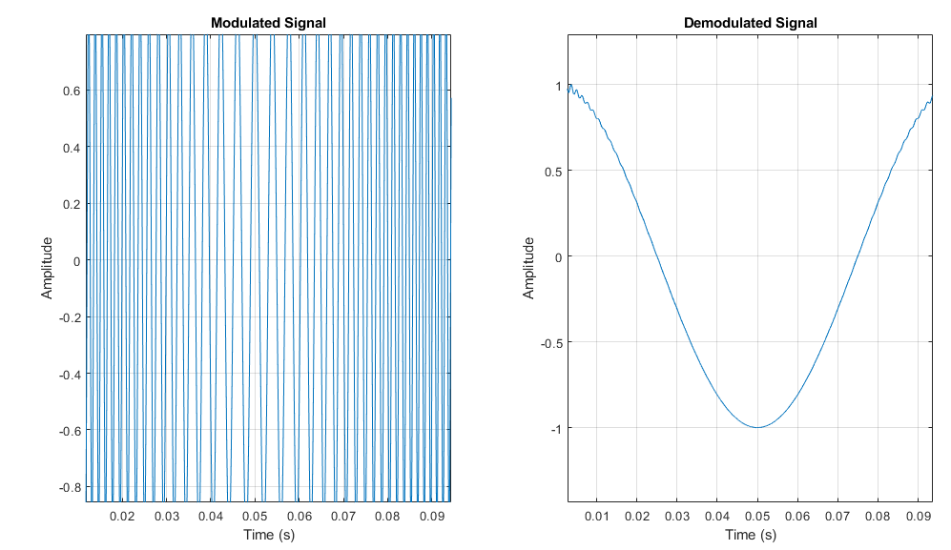

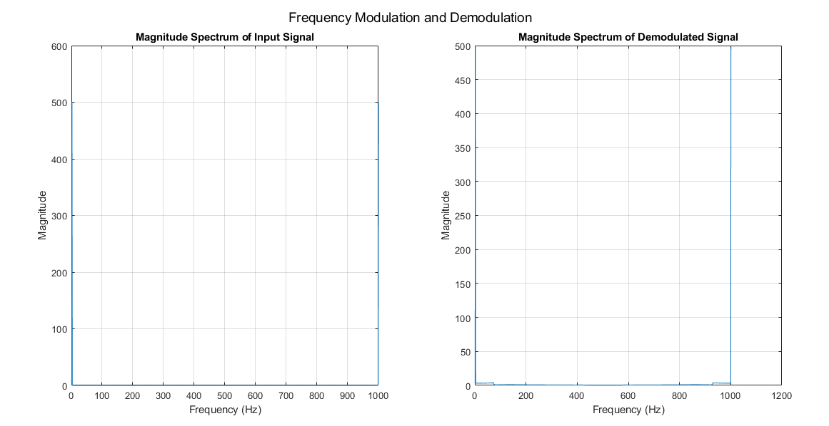

***Explanation:***

***Task 2 – Hardware Procedure***

* First of all energize CT-3000 communication Trainer by applying 220VAC.
* For frequency modulation and demodulation, FM module is inserted in socket 4 and FM Carrier synchronizer module is inserted in socket 2.
* Set the message signal AF of 1 KHz and carrier signal RF of 10MHz directly from trainer at J1 port of FM module.
* Then, frequency modulated signal is observed, at J2 of FM module, on oscilloscope by using prob.
* Now, J2 of FM module is connected to J1 of FMCS module by using connecting wire and demodulated signal is observed at J2 on oscilloscope by using prob. Show the output to an instructor.

***Observations:***

***Circuit:***

***Input Waveform:***

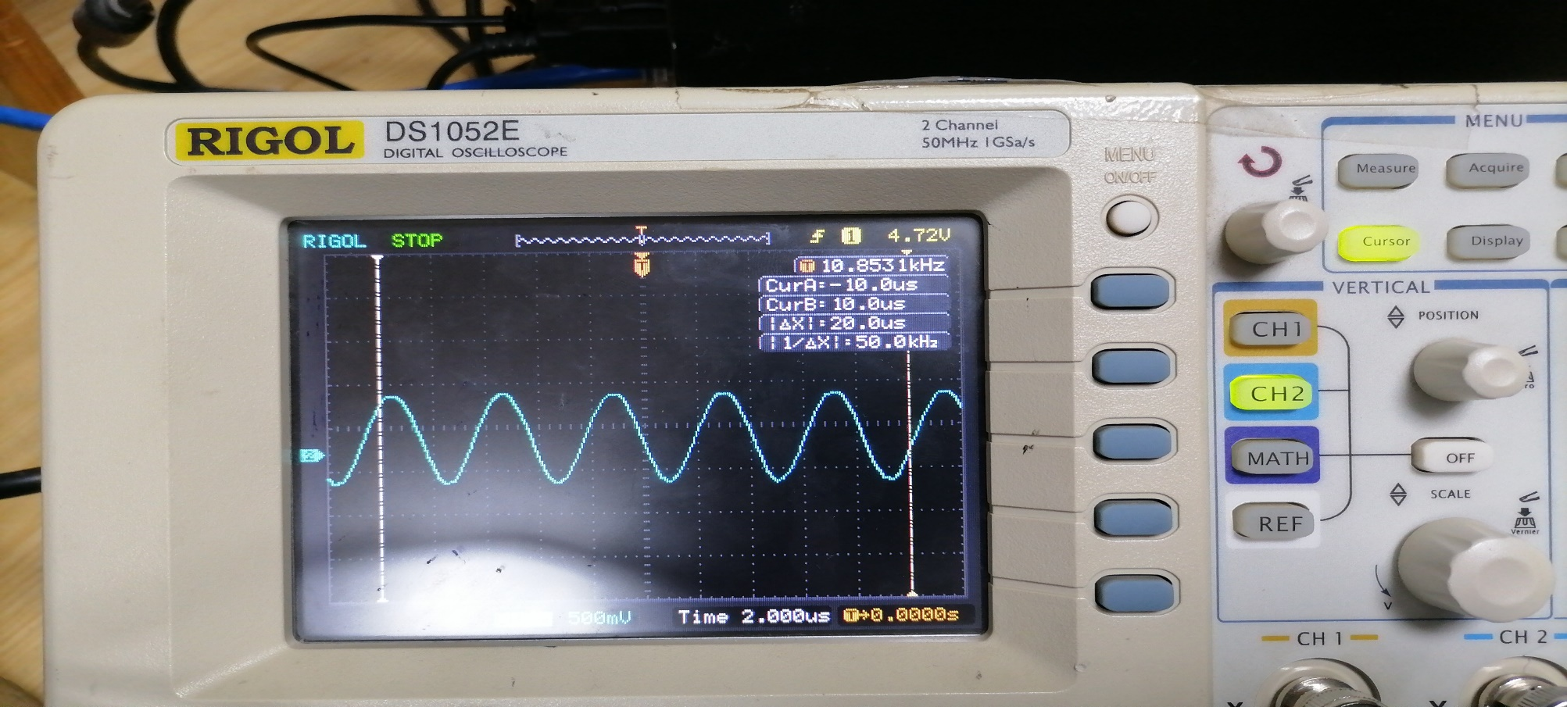

***Carrier Waveform:***

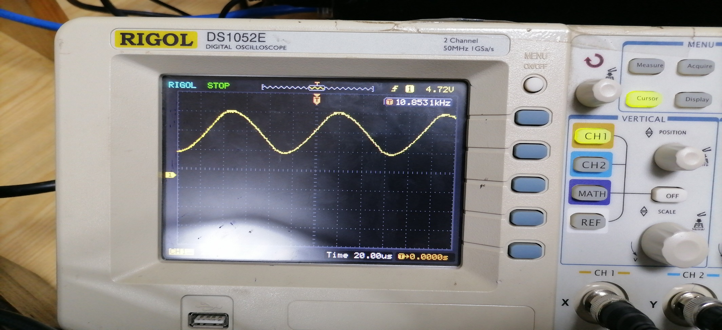



***Modulated Waveform:***

***Demodulated Waveform:***

***Explanation:***

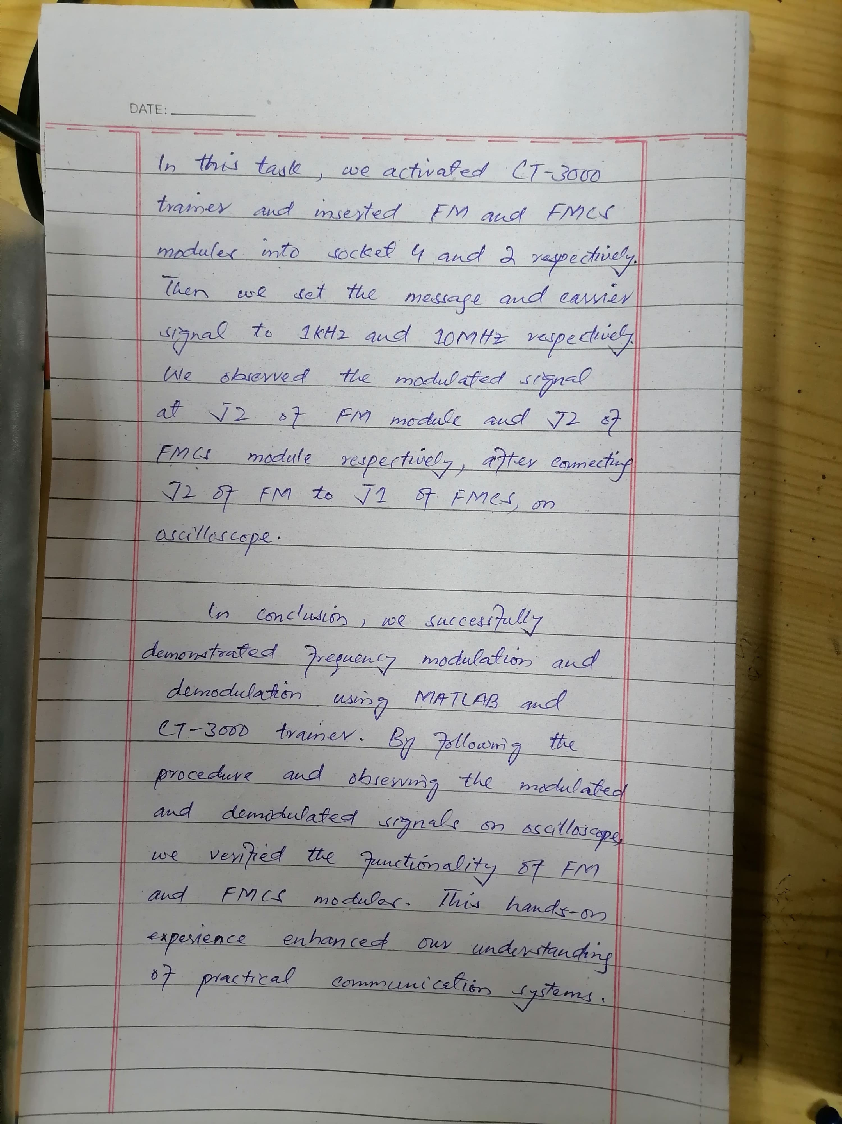

***Conclusion:***

